Emilio Ramos Monzalvo

Syracuse University

IST 719 - Section 0707

Summer 2021

Work in Progress Report

U.S. Petroleum generation

**A Problem Statement**

**I. Dataset**

The dataset obtained from the eia.gov website contains information on the generation of petroleum liquids in the US. The table breaks it down by State and Sector rather than an aggregated overview in the US. The sectors include All Sectors, Electricity Utility, Independent Power Producers, All Commercial, and All Industrial. This means, that there are 5 rows for each of the 50 states plus DC. For each one of these combinations, there is a time series corresponding to it for each month from January 2001 to May 2021. I used the melt command to create a long table rather than a long table with multiple columns per date.

**II. Compelling Story**

The production of petroleum has become a highly controversial topic in the world. The generation and use of petroleum are linked to climate change, fracking, and the destruction of natural environments. Consequently, the United States has taken a stand to limit the production of petroleum in the early 2000’s. The dataset will provide insight through visualizations to prove if the United States’ stand on petroleum generation did impact the total generation over time.

**III. Audience**

The story and visuals are meant to give insight to the population in the United States that understands the problems with the production of petroleum. In other words, the younger generation that want to change the world by stopping climate change.

**IV. Questions**

1. Did the U.S’ production of petroleum slow down after Climate Change became a hot topic?
   1. C.I. Petroleum Generation Over Time
   2. C.II. Decomposition of Petroleum Over Time by State
2. Which sectors are creating the most petroleum?
   1. C.IV. Petroleum Generation Over Time by Sector
   2. C.V. Petroleum Generation by Sector
3. Are there any state exemptions? I.e., is there any states that act differently?
   1. C.II. Decomposition of Petroleum Over Time
   2. C.III. Decomposition of Petroleum by State

**B Poster Sketch**

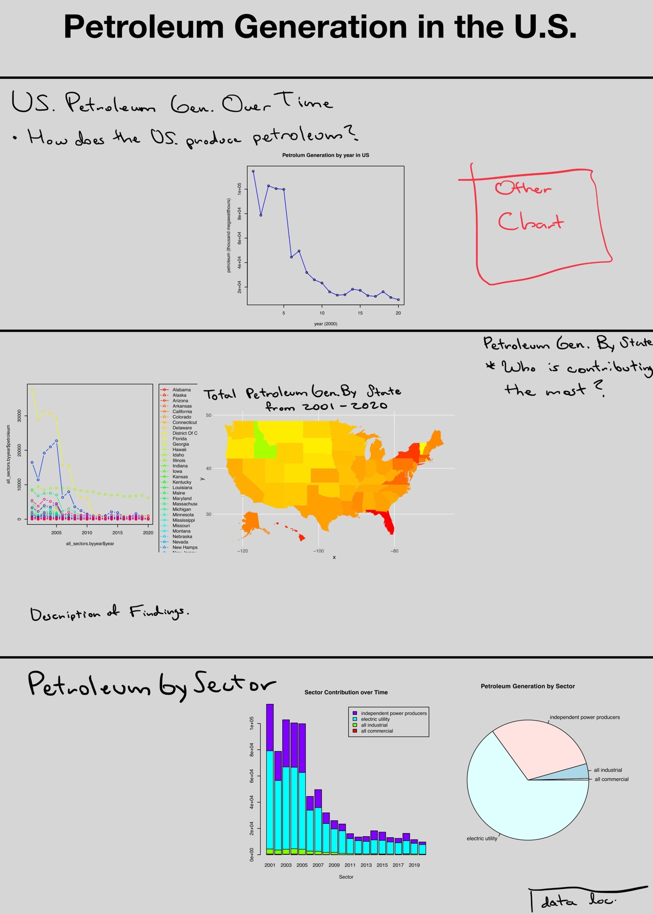

**C Charts**

**I. Petroleum Generation Over Time**

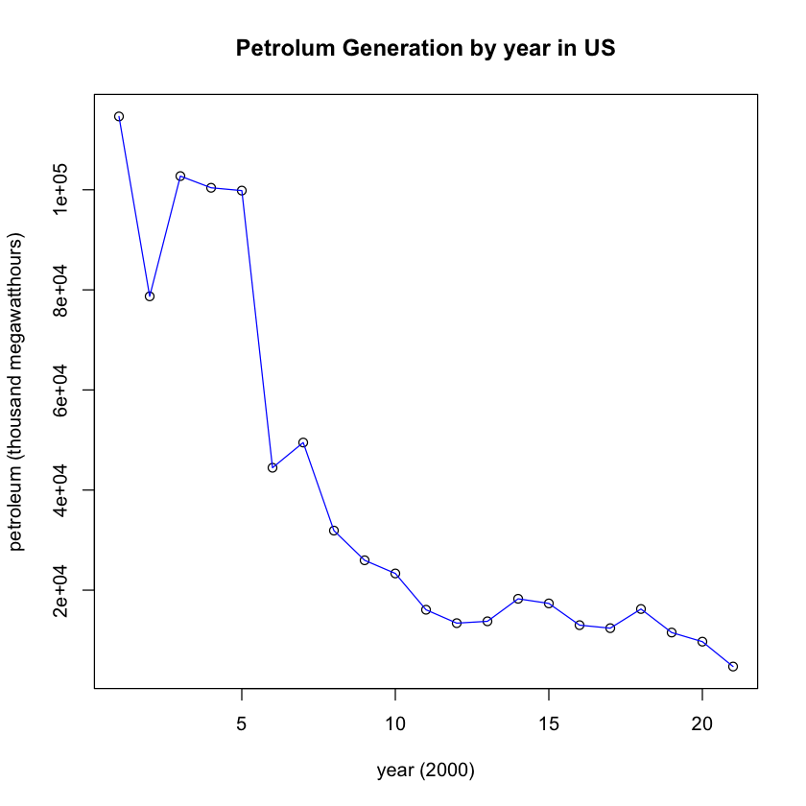

**C.II. Petroleum Generation Over Time by State**

**C.III. Petroleum Generation by State**

**C.IV. Petroleum Generation Over Time by Sector**

[MAP of US with States colored by Contribution]

**C.V. Petroleum Generation by Sector**

